1. **app.module.ts file**:
   1. Each component is declared in this file. 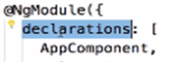
2. **tslint.json**: Where all code standards are defined. The command 🡺 ng lint checks for code standard violation against the rules defined in this file.
3. **Karma.confg.js**: Config file for karma which is responsible for running unit tests.
4. **App.component.spec.ts**: spec.ts extension file contains unit tests for the component.
5. **protractor.config.ts:** configuration of e2e tests.
6. **Angular.json:** All specifications about what should happen when we give commands such as ng serve, ng build, ng e2e etc.
7. **There is a lecture:009 step 07 which contains complete info about different files and folders in angular project. I’m pasting here.  
   +++++++++++++++++++  
   **
8. **App folder**: This folder contains all our angular code.   
   All the components and modules would be in here.
9. **Assents** **Folder**: Containing all the images.
10. **Environments Folder:** When we develop app, we deploy in multiple environments. Local, Development, QA, Test, Production.   
    Configuration for each type of environment, goes into this folder.
11. **Tsconfig.json file**:  
    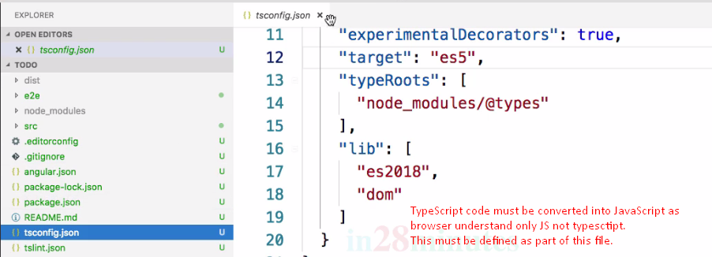
12. 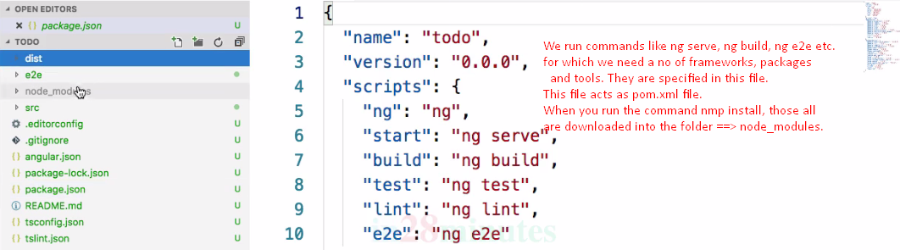  
    **NOTE**: When we run ng new, npm install command is executed automatically.
13. **.gitignore file:** Specifying the files which should not be committed to version control.
14. **Main.ts and index.html:** These two files are responsible to bootstrap our angular app.
15. **Polyfills.ts**: To fill the gaps for the js codes b/w the different browser. Actually, to make js code compatible.
16. **Styles.css:** Having global app styles.
17. **test.ts:** this file is the starting point for running the unit tests during the command 🡺 **ng test**
18. **tsconfig.json:** How to convert typescript code into js.  
    ++++++++++++++++++++++++++++++++++++++++++++++++